|  |  |
| --- | --- |
|  | Add Server to Auto Scripts |

Table of Contents

1 Purpose 3

2 Description of the AutoScript Process 3

3 Adding An Instance to the process 4

4 Description of the Scripts 9

**Summary**

|  |  |
| --- | --- |
|  |  |
| **Author(s)** | Rob Sewell |
| **Role** | Senior Database Administrator |
| **Title** | Add Servers to auto scripts |
| **File Name** | Add Servers to auto scripts.docx |

**Sign-Off**

|  |  |  |
| --- | --- | --- |
| **Name** | **Role** | **Date** |
|  |  |  |
|  |  |  |
|  |  |  |
|  |  |  |
|  |  |  |

|  |
| --- |
| 1 Purpose |

This document is deigned to step through the process of adding a server to the auto-script process to enable a DBA to easily add a new (or existing) Server to the process.

|  |
| --- |
| 2 Description of the AutoScript Process |

The Auto-Scripts process is designed to improve and standardise the SQL Server estate by ensuring that all servers have the required scripts installed. It will also enable easy targeting of servers either for PowerShell automation or for the addition, upgrade or deletion of scripts.

Having all of the SQL instances recorded in a single place will also enable quick and easy resolution of data gathering about the servers and this information can be made available to other people to self serve the information reducing the workload on the DBA team

The systems uses the DBADatabase database hosted on the instance XXXXXXXXX.

The InstanceList table holds information about each instance, the servername, instance name and port. Further columns will need to be added to this table to enable more fine grained targeting of servers such as Environoment (PROD,TEST,DEV), HADR, System and Programme

The ScriptList table holds information about the scripts, the name, description and location

The InstanceScriptLookup table is the lookup table used to identify the scripts that need to be updated and the instances they need to be run on.

There are also three tables in the info schema which hold information to be used for reporting

Info.ScriptInstall shows which scripts have been installed on which servers and is populated using an Agent job running on XXXXX weekly

Info.ServerOSInfo shows Windows OS level information such as processors, RAM, Operating System version and IP Addresses. this is updated using a Powershell script on XXXXXXXXXXX

Info.SQLInfo holds SQL configuration information and is populated by the Agent Job Auto DBA Database SQL Info which runs weekly on XXXXXXX

Each of the three Info tables can be accessed via the Excel sheet DBADatabaseTables located

|  |
| --- |
| 3 Adding An Instance to the process |

It is important to follow these steps carefully, they should only be performed by a DBA and none of the scripts involved should be altered in any way without discussion with the Team Leader

1. Check if the instance has been added by connecting to AOLI-SYSTEM-DBA,54703 and running   
   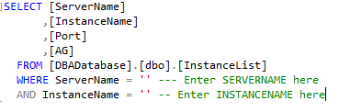
2. Navigate to ……………. and add the server and the instance name (even if it is default) to the spreadsheet AutoScriptTransfer
3. Open the Solution file New Instance Setup.ssmssln located
4. Connect to the instance that you are adding and open the query 10 - Create DBA-Admin Database.sql
5. Alter Lines 34 and 38 for the file paths for the DBA-Admin database files to match that servers configuration
6. Run the script
7. Connect to The Server with the DBADatabase and open the query Example - Server Data Load.sql
8. Fill in the Server Name, Instance Name, Port and AG Status EVEN IF THEY ARE DEFAULT

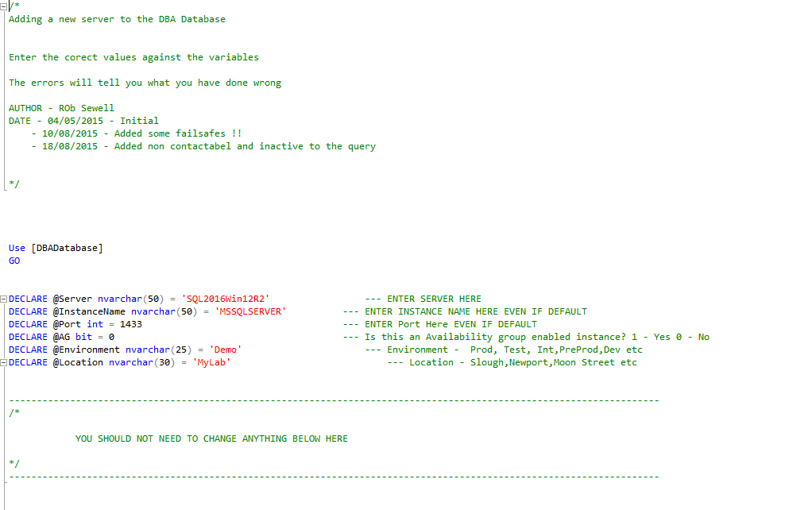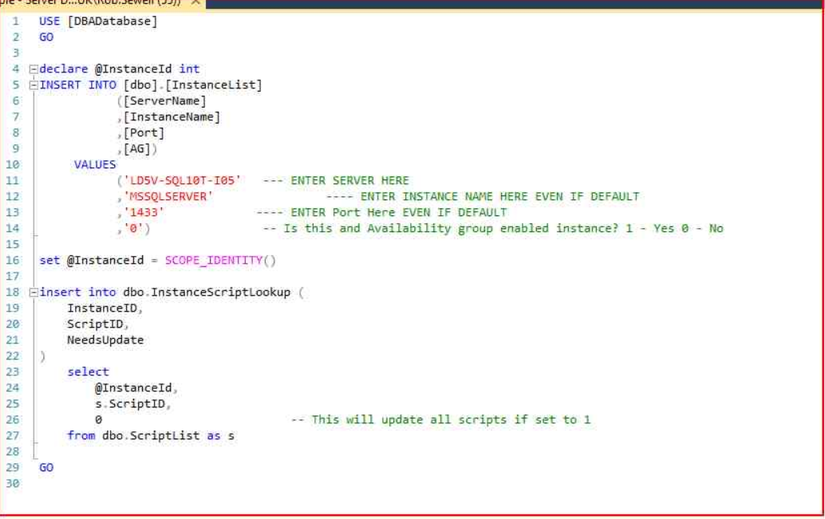

1. Run the script
2. Open the query EXAMPLE - Update the Needs Update Flag.sql enter the Server Name and Instance Name EVEN IF THEY ARE DEFAULT on lines 38 and 39

Scroll down to Line 66 and uncomment the scripts that need to be installed. NOTE – there are 4 backup jobs named XXXXX . You only need to choose one of these. Development and Test servers should backup using the DEVJob jobs and Production Servers using the PRODJob jobs. The location is the location for the backups so DC1 Servers should back up using the DC1 jobs and DC2 Servers should backup using the DC2 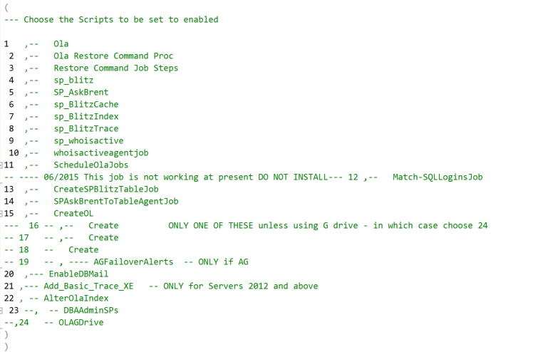 jobs. Script 19 AG Failover Alerts should obviously only be applied to instances with Availability Groups

When happy, run the script

1. Open the query EXAMPLE - Query For Needs update =1.sql which will show which instances and scripts will be updated the next time the auto-install script runs
2. Either – Leave the automated job to run overnight which will install any scripts required or connect to XXXXXX and run the Auto Script Install agent job. Once this has finished running open the log file located \\XXXXXXX\LogFiles and named AutoServerUpdate_DATE.log You may find that the Agent job has completed successfully but the script installation has failed. The errors should be obvious to see in the log file. For Example the below log shows that the user had not been correctly set up  
     
   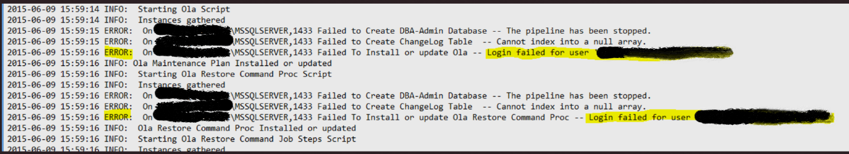  
     
   a successful log will look something like this  
     
   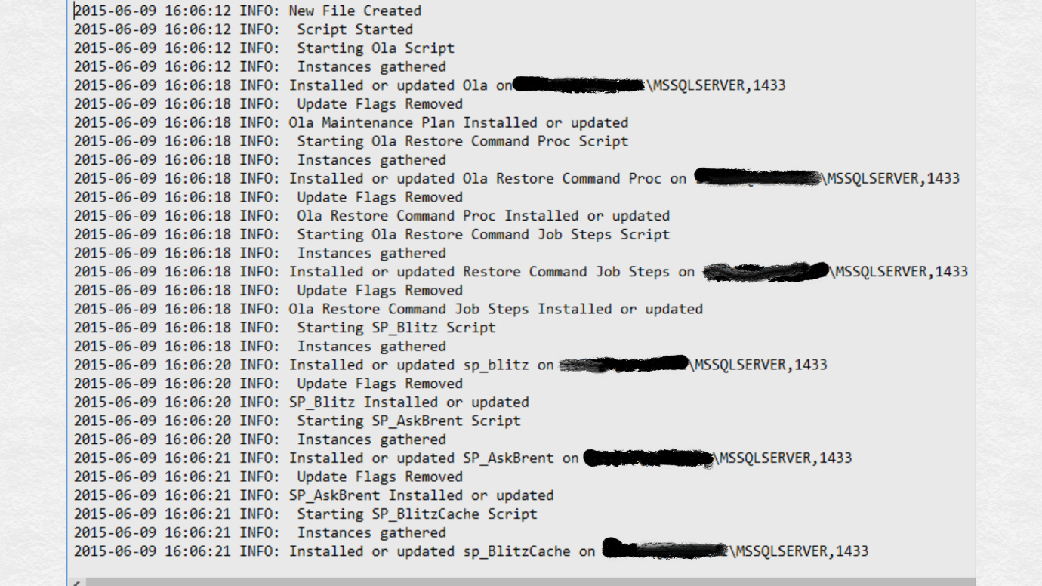
3. Connect to the instance you are adding to the process and check the ChangeLog Table in the DBA-Admin database which should look like this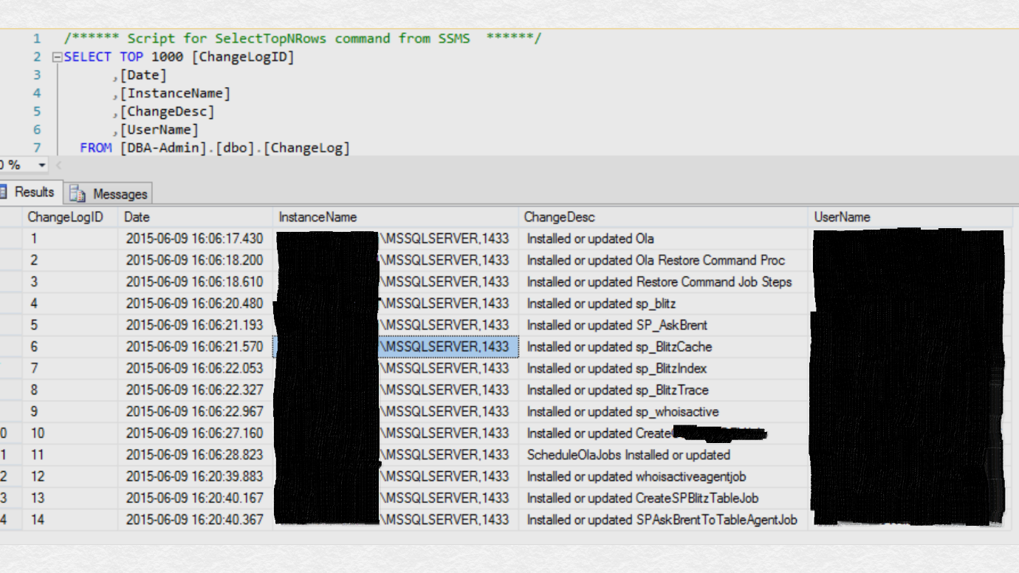

Any future changes to the server should be recorded in the Change-Log table to assist with any problem resolution and as a quick way to see what changed when.

1. Open the Agent Job Activity Monitor and check that the jobs have been created and scheduled   
   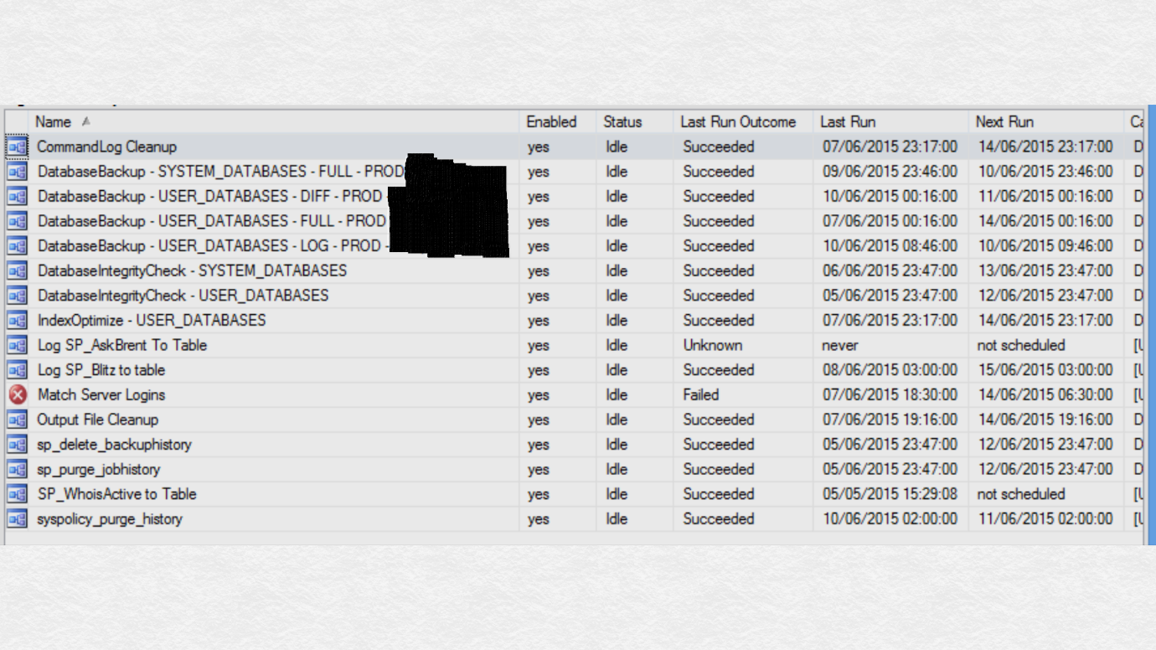
2. Run the System Databases FULL and User Databases Log jobs and check that the files have been created in the share you have specified. Notice that there is a DatabaseRestore.txt file which will contain the Restore scripts required to restore the database to the latest available point using the backups taken.
3. Disable any other maintenance jobs
4. Return to the Excel Sheet and complete the columns for the instance that you have added

|  |
| --- |
| 4 Description of the Scripts |

00 - Create DBA Database.sql

Creates the DBA-Database in the event of disaster or requirement to recreate the solution

10 - Create DBA-Admin Database.sql

Creates the DBA-Admin Database on new instances AND gives permission to the Service Account

100 - who_is_active_v11_11.sql

The whoisactive script will provide information about currently running processes

110 - Create WhoisActive to Table job.sql

Runs the WhoIsActive Procedure 5 times every 10 seconds and logs to a table in DBA- Admin Database

120 - Create Match Server Logins Job.sql

A job to match logins across Availability Groups

130 - Create SPBlitz to Table Job.sql

This job will run the sp_blitz sp and log to a table. SP_Blitz is a health check that will identify common issues or poor configuration

140 - Create SPAskBrent To Table Agent Job.sql

This job runs SP_AskBrent which will run for 30 seconds and log to a table in the DBA-Admin Database. This should be the first port of call for troubleshooting as it will

* Look at sp_who or sp_who2 or sp_WhoIsActive for blocking or long-running queries
* Review the SQL Server Agent jobs to see if a backup, DBCC, or index maintenance job was running
* Query wait statistics to figure out SQL Server’s current bottleneck
* Look at Perfmon counters for CPU use, slow drive response times, or low Page Life Expectancy

150 - OLA Backup – Prod DC1.sql

Creates the Ola Hallengren Solution providing intelligent backups, index maintenance and integrity checks with the backups going to the Prod DC1 Share – This should be used for DC1 Servers. Job schedule will need to be altered so that all backups do not happen at the same time

160 - OLA Backup - Dev DC1.sql

Creates the Ola Hallengren Solution providing intelligent backups, index maintenance and integrity checks with the backups going to the Dev DC1Share – This should be used for DC1 Servers. Job schedule will need to be altered so that all backups do not happen at the same time

170 - OLA Backup - Dev DC2.sql

Creates the Ola Hallengren Solution providing intelligent backups, index maintenance and integrity checks with the backups going to the Dev DC2 Share – This should be used for Slough Servers. Job schedule will need to be altered so that all backups do not happen at the same time

180 - OLA Backup - Prod DC2.sql

Creates the Ola Hallengren Solution providing intelligent backups, index maintenance and integrity checks with the backups going to the PROD DC2 Share – This should be used for DC2 Servers. Job schedule will need to be altered so that all backups do not happen at the same time

190 - Add Availability Group Alerts.sql

Adds alerts and operators to notify the DBA team of Availability group failovers

20 - Ola MaintenanceSolution (1).sql

Adds the Ola Hallengren Solution stored procedures

200 - Enable DBMail.sql

Enables DBMail

30 - RestoreCommand Proc.sql

Adds the stored procedure to create the DatabaseRestore text file holding the current restore scripts for each database on the instance

40 - RestoreCommand Job Steps.sql

Adds a step to each backup job to call the above procedure

50 - sp_Blitz.sql

Adds the sp_blitz stored procedure

60 -sp_AskBrent.sql

Adds the Ask Brent stored procedure

70 - sp_BlitzCache.sql

Adds the Bliztzcache stored procedure which provides in depth analysis of the SQL cache

80 - sp_BlitzIndex.sql

Adds the BlitzIndex stored procedure to provide in depth analysis of idexes

90 - sp_BlitzTrace.sql

Adds the Blitztrace stored procedure

EXAMPLE - Query For Needs update =1.sql

Sows the current instances and scripts with needsupdate = 1 which will be installed on next runoff the Auto Script Install Agent job

Example - Script Data Load.sql

Script to add a new script to the solution

Example - Server Data Load.sql

Script to add a new server to the solution

EXAMPLE - Update the Needs Update Flag.sql

Script to set the Needs Update flag to 1 for an instance and a number of scripts. Use this as the basis of any script to change the update flag for a number of servers

|  |
| --- |
| **8 Document Log** |

|  |  |  |  |
| --- | --- | --- | --- |
| Version | Name | Pages Affected | Date |
| Initial | Rob Sewell | All | 10/06/2015 |
|  |  |  |  |
|  |  |  |  |
|  |  |  |  |
|  |  |  |  |
|  |  |  |  |
|  |  |  |  |
|  |  |  |  |
|  |  |  |  |
|  |  |  |  |
|  |  |  |  |
|  |  |  |  |
|  |  |  |  |
|  |  |  |  |
|  |  |  |  |
|  |  |  |  |
|  |  |  |  |
|  |  |  |  |
|  |  |  |  |
|  |  |  |  |
|  |  |  |  |
|  |  |  |  |
|  |  |  |  |
|  |  |  |  |
|  |  |  |  |